Chapter I
Async code is any proccess that happens at a different time than the current thread of event management from the main program. Async can be expressed in functions called by events or timeouts, as with more recent features such as Jobs and Promises.

Notes
- Console methods are not part of JavaScript, instead they belong to the hosting environment.
- Console methods can behave differently between browsers, so evaluating code with console.log(…) might lead to different results over different platforms. It’s better to use an IDE’s inbuilt debugger, like Atom or Visual Studio Code.
- All programs are broken into small chunks that execute at certain time. Before ES6 the language had no way to create true asynchronous code, there only existed a single event loop that processed pieces of code as they were presented.
- This creates 2 parts of any code we can write: a now part that executes right away and modifies what it has to and a later part that executes at a certain point in the future because of timeouts, listeners, callbacks or other reason.
- Async is about the gap between now and later, parallel is about things happening simultaneously.
- JS doesn’t share data across threads, so there is no reason to worry about data being misrepresented by a value being called, modified or returned by different functions at the same time due to errors in the way the engine works.
- ‘Deterministic Algorithms’ are those that produce the same answer every time as long the same input is provided and the only changes in the result can be determined by an external actor. JavaScript behaves as a deterministic language most of the time, but if it tried to run code in a parallel way while sharing data from the threads it would produce inconsistent, nondeterministic results every time.
- Race Condition occurs when two functions compete against each other altering values and firing events and if they interact it can generate vastly different results, creating a situation of non-deterministic behavior. This is a type of ‘bug’ that can and must be fixed by the programmer.
- There are situations that can generate non-deterministic results but they are related to the order a function is called, not to the way JS works.
- JS is single threaded and has run-to-completion behavior, meaning: if it has to run function ‘a’ and function ‘b’ it will never start running function ‘b’ until ‘a’ ends.
- Concurrency is when two or more ‘processes’ are executing simultaneously over the same period, regardless of their operations happening in parallel or not.
- All is handled through the event loop queue – there is no way to skip the line. Events are passed to it and will be solved in order until there is no more.
- Non-interaction can produce non-deterministic behavior, but in this context it is acceptable – it doesn’t matter.
- Interaction is inevitable in most projects and much of the time we should add safeguarding mechanisms that prevent nondeterminism.
Gate: create a condition that checks if all values to be used are properly in place, if not – do nothing and let the next function that will interact with the value complete the process.
Latch: a condition that checks if an answer on the result storage has already been issued and if it is, cancel the function that was going to modify it. In other words, it only accepts the first that fired and completed.
- Cooperation: I’m not sure why it is called like this… Cooperation means dividing big tasks into smaller chunks that do not clog up the event loop queue. This is done by providing limits to the amount of stuff a certain chunk can handle each time it executes, thus providing the hosting environment a chance to slip other processes into the queue in between chunks of the original big process. I guess It’s called ‘cooperation’ because it allows for other functions and events to work alongside it instead of hogging all the resources for itself until it finishes.
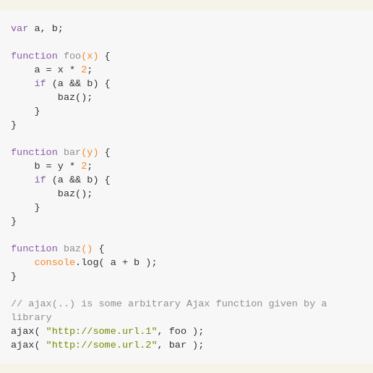Figure 1: Gate Example, only work if all values are in place.
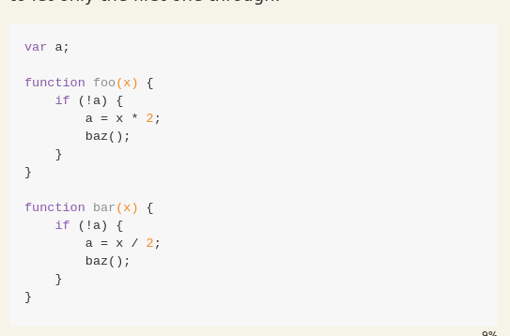Figure 2: Latch example, only report the one that fires first - prevents second ones.
- Jobs are a new concept introduced in ES6, they are essentially setTimeout(…, 0) made into an official method. Jobs work by layering at the top of the event queue, being added to the stack in the last ‘tick’ of the current process. They can add more jobs and thus it is possible to create an infinite loop this way because placing itself at the top of the stack means nothing else will be resolved until that is ready.
- Statement ordering: in JS most of the time the code will be executed in the way it was written and that will prevent most bugs. But sometimes when code is compiled, like when using Node, it will try to optimize and in the process change the order or the way it presents many things. It’s worth knowing this can happen but it rarely happens.

